Objective:
This status report serves as a checkpoint after the submission of the project proposal, allowing you to reflect on the progress made so far. This assignment encourages you to review your progress based on your submitted proposal and timeline.
Deliverables:
- Progress Overview: Provide an update on the tasks completed since the proposal submission. Explain any features or milestones that were started or finished during these two weeks.
Over the past couple of weeks, we have made very strong progress in the early stages of our mobile application. We decided on a project concept and also picked out the core features that will be in our application. We also created a GitHub repo to manage the file and collaborate on the development if this app.
- Completed Milestones: Identify and briefly explain any milestones that have been completed, along with supporting evidence (such as screenshots, wireframes, or code snippets).
Team 3’s milestones have been updated to reflect recent changes in project requirements, and all completed work aligns with the tasks outlined in our project timeline. Our application will incorporate stack‑based navigation, and at this stage, the milestones for Week 1 and Week 2 have been successfully completed.
For the milestone “Build the base .NET MAUI project with navigation and placeholder screens,” an initial .NET MAUI application was created with example screens to establish the foundation for future UI development.
For the milestone “Create initial data models and load sample agenda content,” sample agenda data was implemented using SQLite within the example application. This demonstrates that the team has successfully integrated local data storage and retrieval.
A group GitHub repository will be created to support collaboration and version control. The repository can be accessed here:
https://github.com/N2025po0j4ri/IT3048Week9Update
The screenshots included below serve as supporting evidence of the completed milestones and current progress. The team will repurpose this repository as development continues, ensuring that stack‑based navigation is fully implemented and that the application aligns with the wireframes and UI expectations outlined in the proposal.

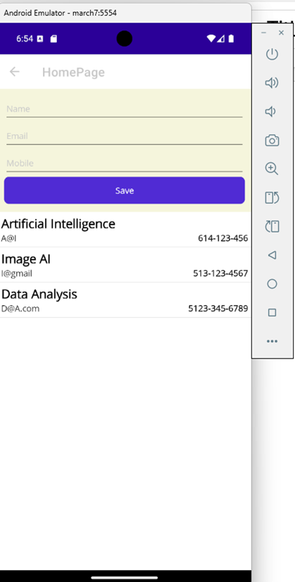
Figure 1 – The SQL database UI code
This screenshot shows the application’s SQLite implementation, including an entry field that allows users to input and store information locally. This demonstrates progress toward the Week 2 milestone involving data modeling and sample agenda content.
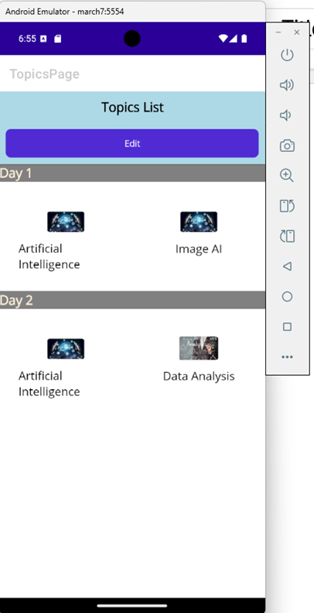
Figure 2 – The agenda home page having events.
This screenshot represents the planned agenda home page layout that will be incorporated into the group repository in upcoming weeks. The final application will include dedicated views for both attendees and organizers, supporting the refined project scope.
- Challenges: Detail any challenges faced during the initial two weeks. Discuss how the team plans to resolve these challenges.
During the first two weeks of the project, Team 3 encountered several challenges related to communication, coordination, and varying levels of technical experience. These issues created delays in meeting early milestones, particularly when developing the initial wireframes and ensuring that all team members shared the same expectations for the project’s direction.
To address communication gaps, the team has agreed to implement clearer guidelines for meetings, progress updates, and task ownership. Moving forward, Microsoft Teams will serve as the primary platform for organizing discussions and tracking ongoing work, while Outlook will be used to communicate deadlines and important announcements. This structure is intended to reduce confusion and ensure that all members remain aligned.
The team also identified skill gaps, especially when working on more complex technical components of the application. To mitigate this, the most technically demanding tasks will be assigned to members with stronger development experience. At the same time, less experienced members will receive support through collaboration, shared learning, and opportunities to contribute to tasks that match their current skill level. This approach ensures steady project progress while promoting growth across the entire team.
By strengthening communication practices and distributing responsibilities based on expertise, Team 3 is confident in its ability to overcome these early challenges and maintain consistent progress throughout the remainder of the project.

- Scope Changes: Addyson
Have there been any changes or adjustments to the scope of the project? If so, explain:
  - Features added or removed: What changes have been made to the features of the app?
    - There have been no features added to or removed from the conference app.
  - Revised app functionalities: If certain features are no longer feasible or have been redefined, detail these changes.
    - We originally designed the app to be accessible for multiple different types of users, such as students, event organizers, conference attendees, and speakers/presenters. However, we received feedback that our project scope is broad, specifically that we should limit the primary users to conference attendees and event organizers.
  - Timeline Adjustments: Explain any necessary changes to the timeline based on new insights, resources, or challenges discovered during the process.
  - Removed optional offline use to assure better quality work for less features.
- Updated Timeline:
Review the timeline based on the progress made and any scope changes. Ensure the updated timeline still supports the successful completion of the app, accounting for new tasks or changes in priorities.
Week 1
- Finalize the project concept, scope, and overall structure.
- Set up the repository, communication plan, and initial wireframes.
Week 2
- Build the base .NET MAUI project with navigation and placeholder screens.
- Create initial data models and load sample agenda content.
Week 3
- Implement the two‑day agenda layout and connect it to sample data.
- Build the session details page and link it to agenda items.
Week 4
- Add favorites/bookmarking and basic local storage.
- Implement searching and filtering for sessions.
Week 5
- Improve UI layout, spacing, and overall usability. Consider both attendee facing and organizer facing views.
Week 6
- Test navigation, data flow, and feature behavior across devices.
- Fix bugs, refine UI elements, and improve performance.
Week 7
- Finalize all features and polish the interface.
- Prepare documentation, screenshots, and final submission materials.
- Next Steps: Outline the key tasks for the next three weeks. Clearly define who is responsible for each task.
Implementing a two-day agenda plan layout, sample data - Niru
Build the session details page and link to agenda items – Niru / Addyson
Add favorites/bookmarking and basic storage – Miles / Niru
Implement searching and filtering for sessions – Niru
Improve UI layout, attendee and organizer facing views – Levi
Test navigation, data flow, and feature behavior – Miles
Fix bugs – Everyone
Refine UI Elements – Levi
Finalize – Everyone
Prepare documentation, screenshots, and final submission materials - Miles
Conference Application App Screenshots
Windows
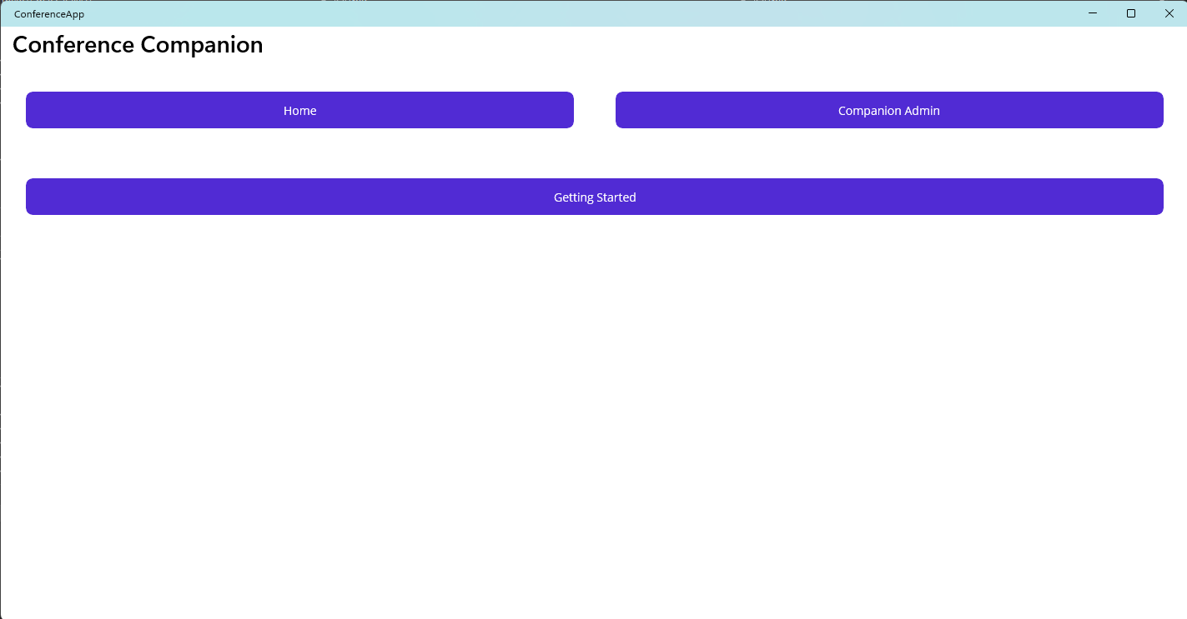
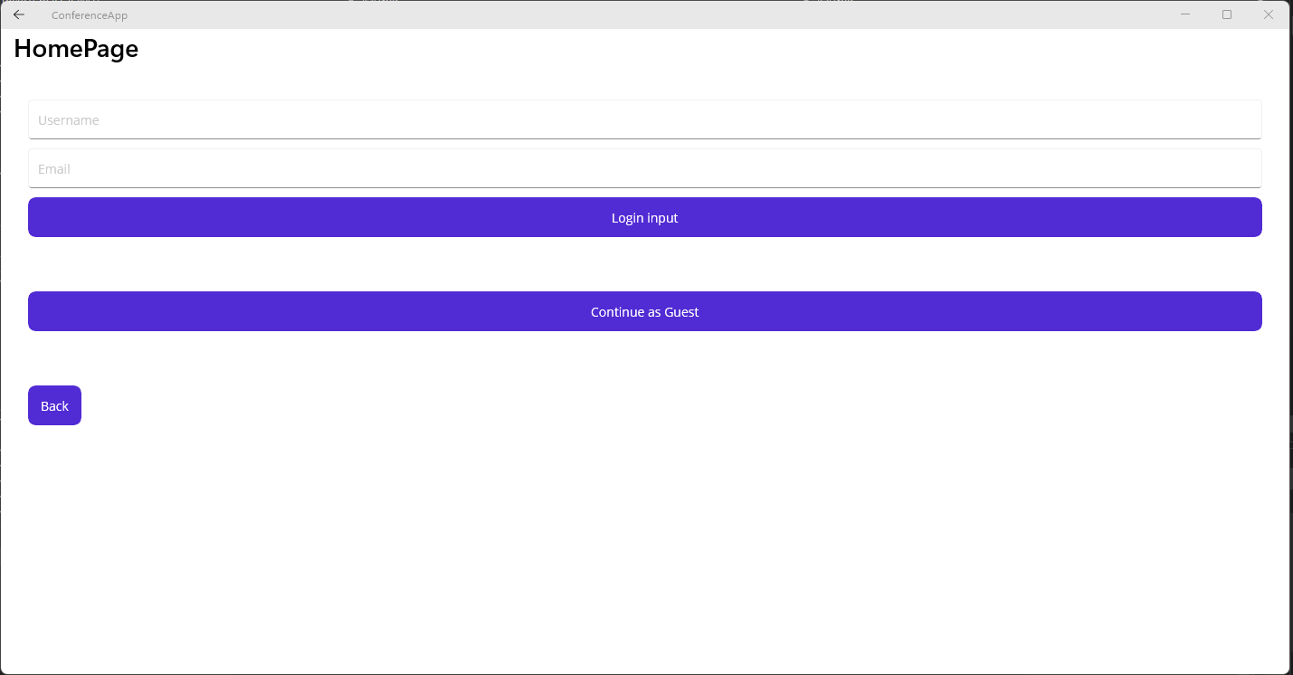
Login with username Nirupama:
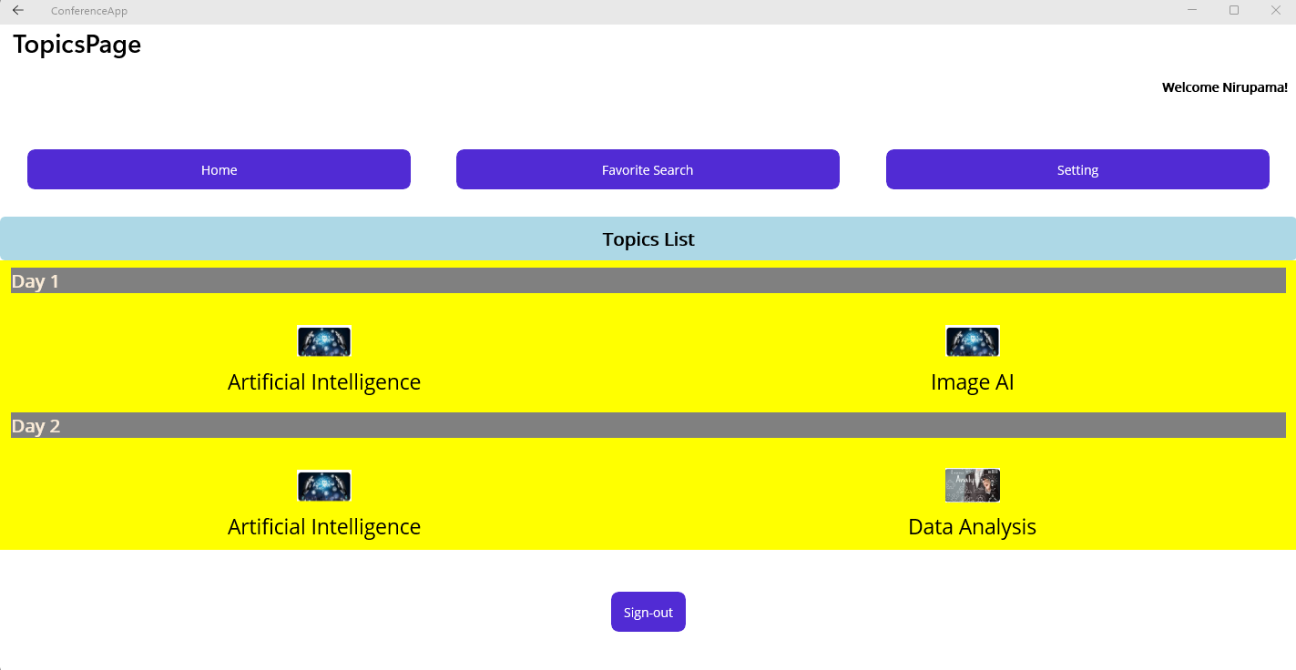
Login as a Guest:
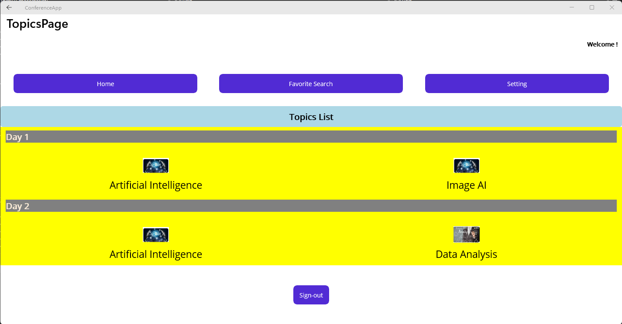

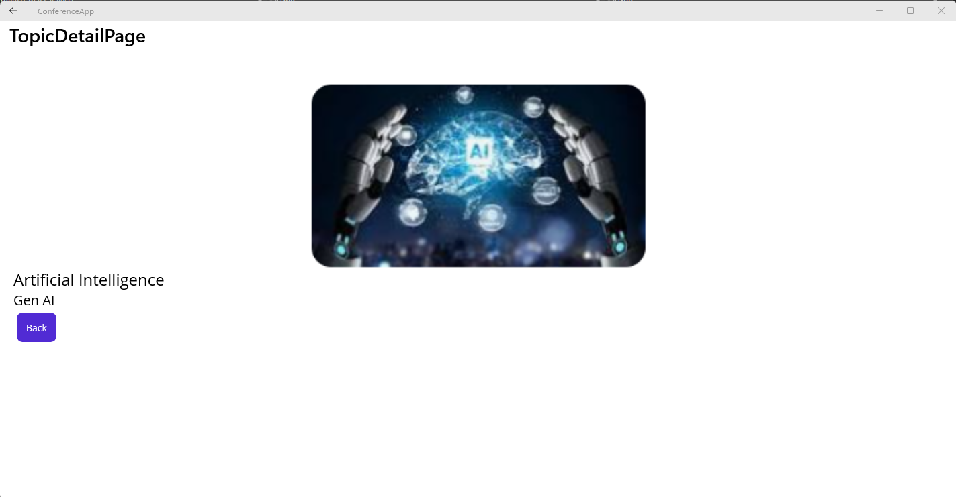
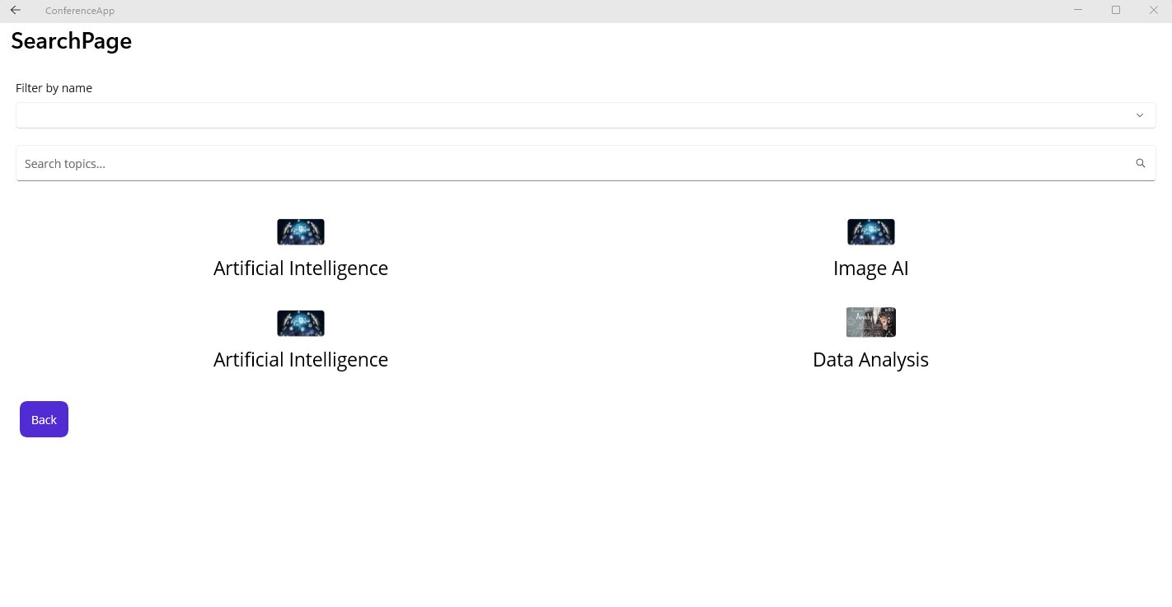
Search:
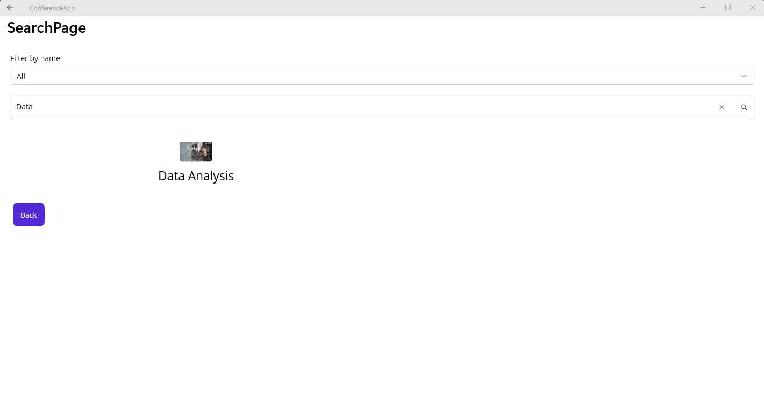
Filter:
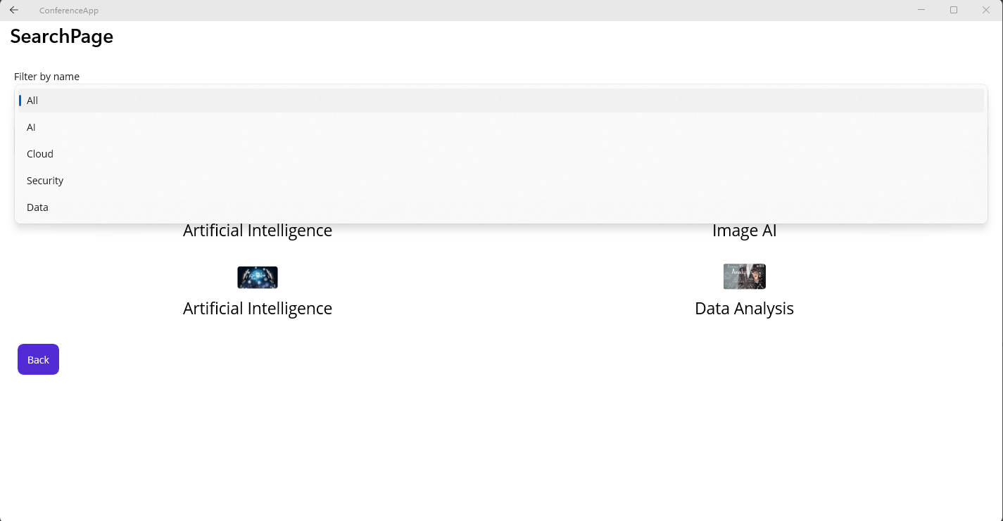
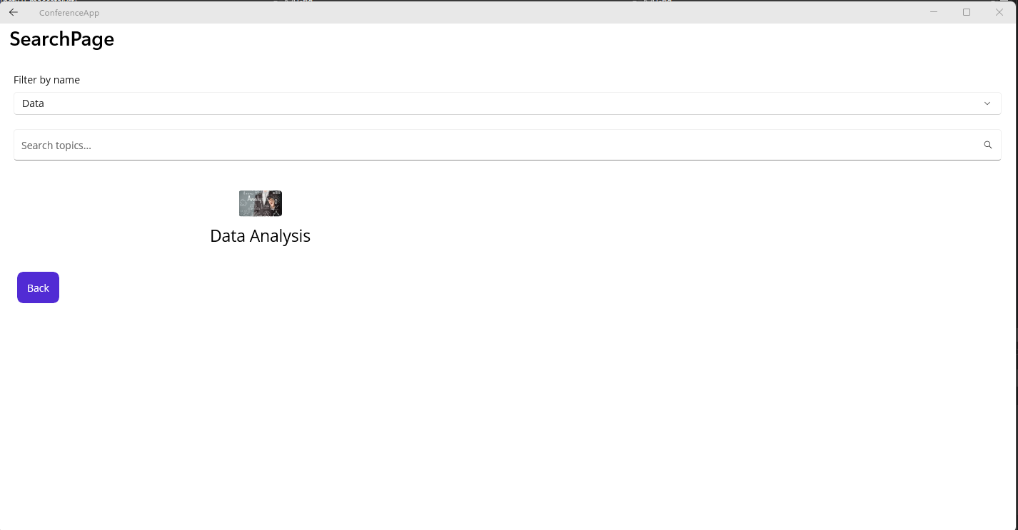
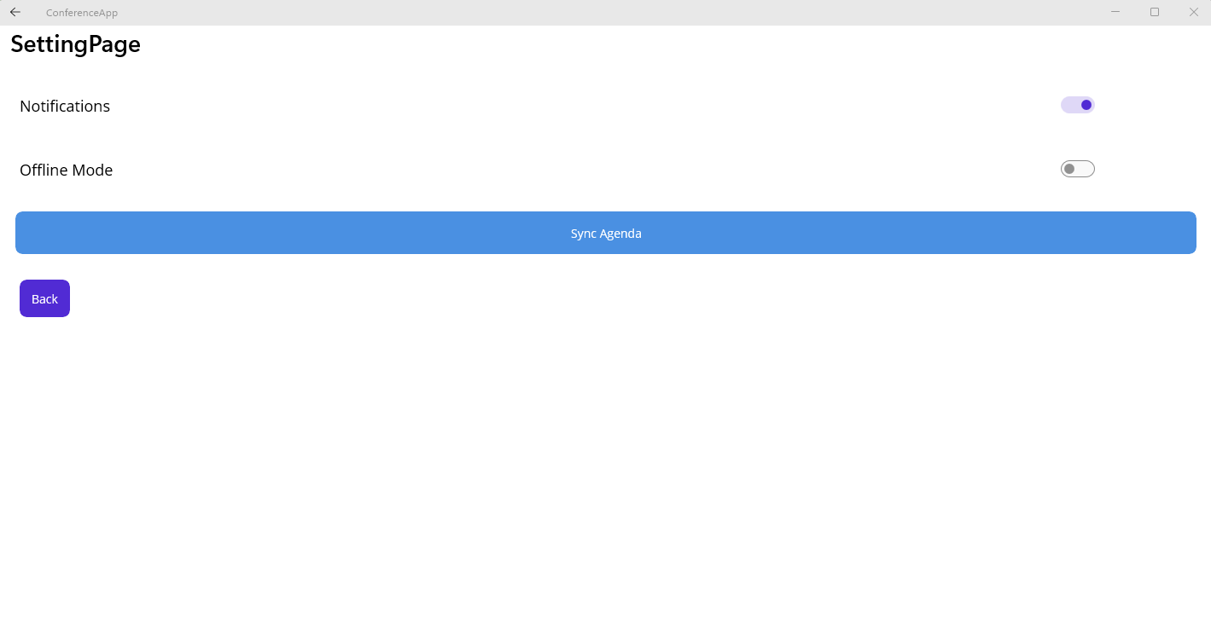
In the first page, click on Companion Admin:
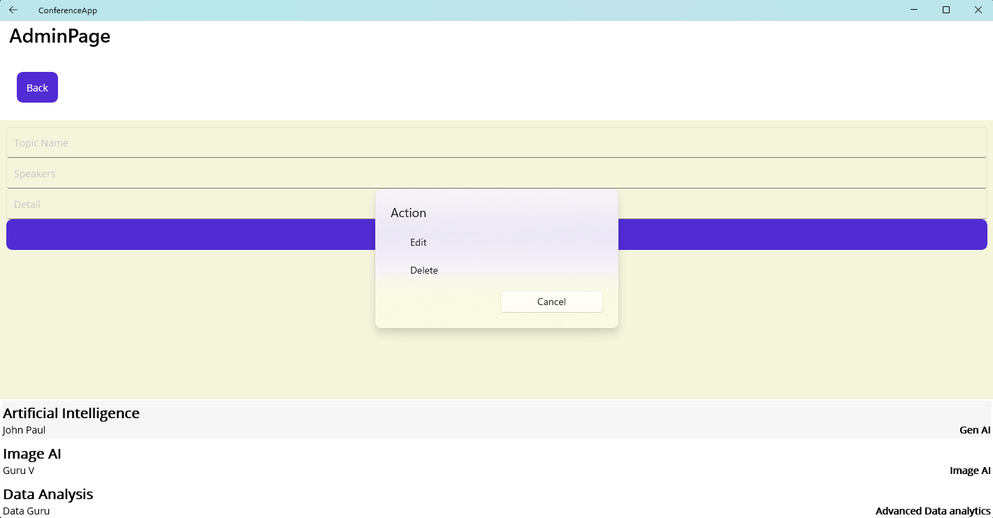

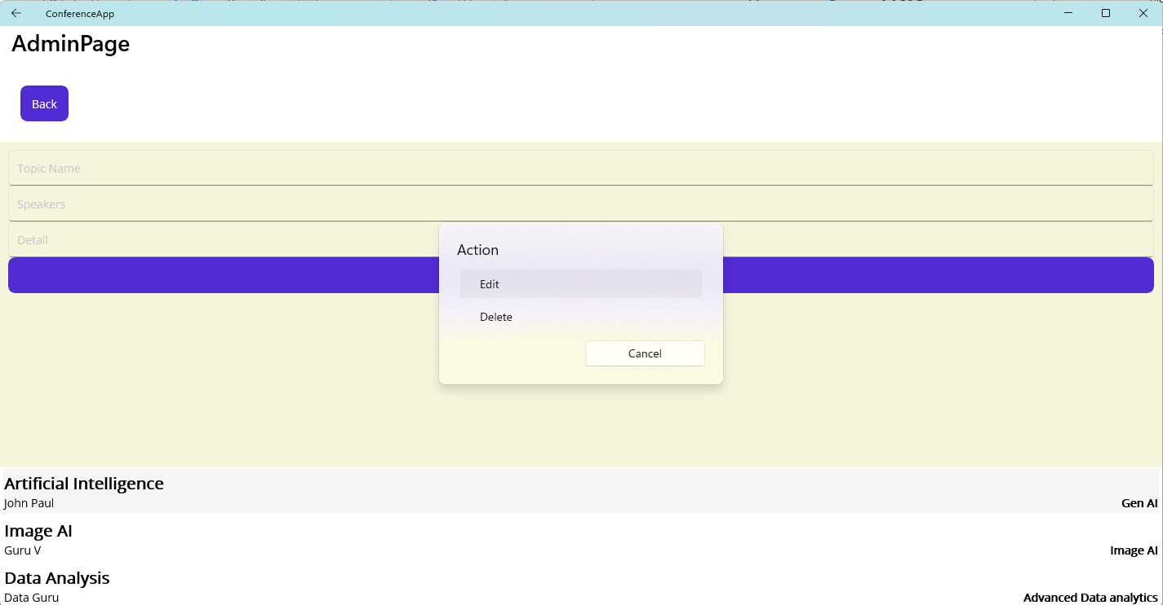

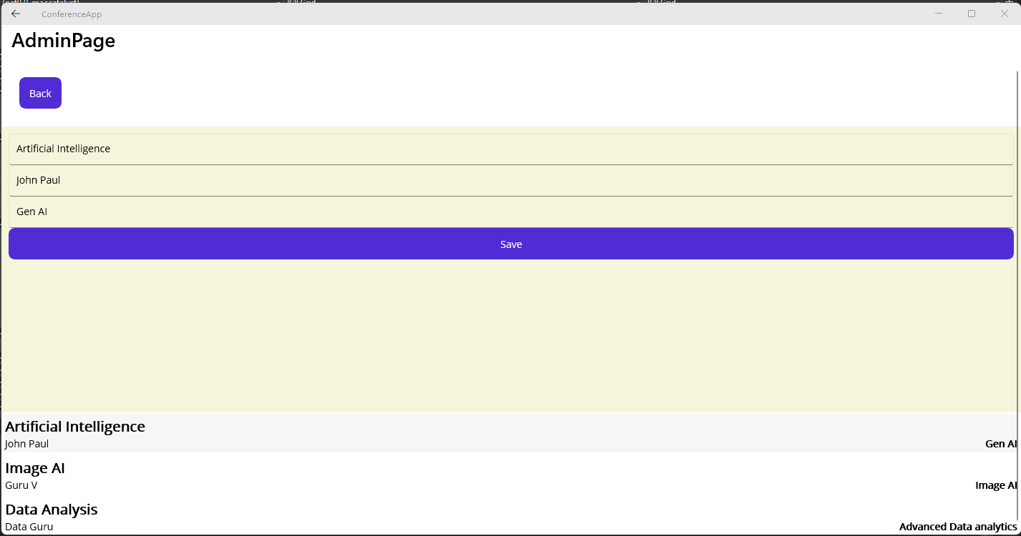

Android
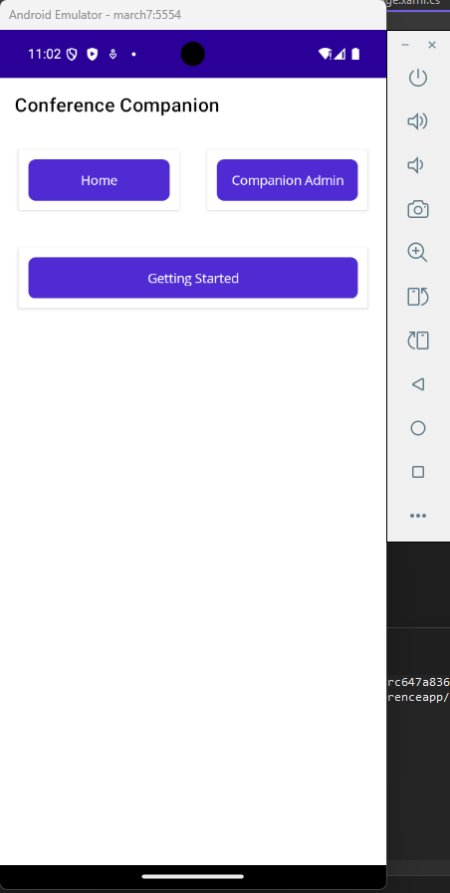
After clicking on “Home”.

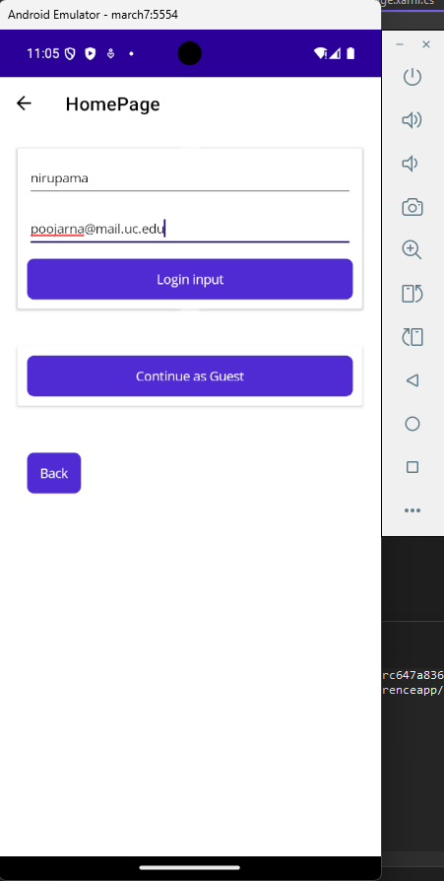
On the click of Login button following pages displayed with a welcome message for the user.
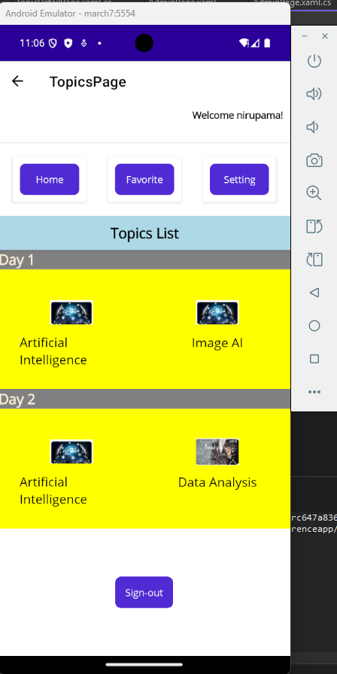
When clicking on “Getting Started”.
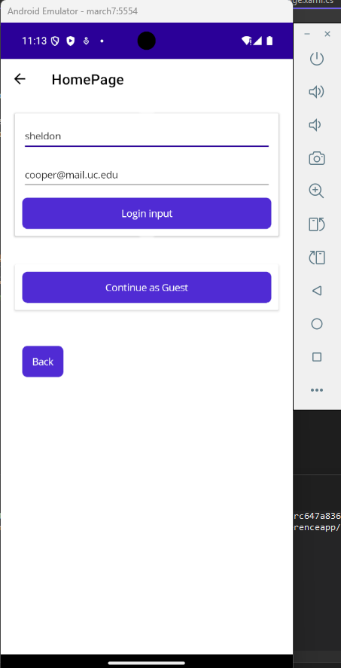
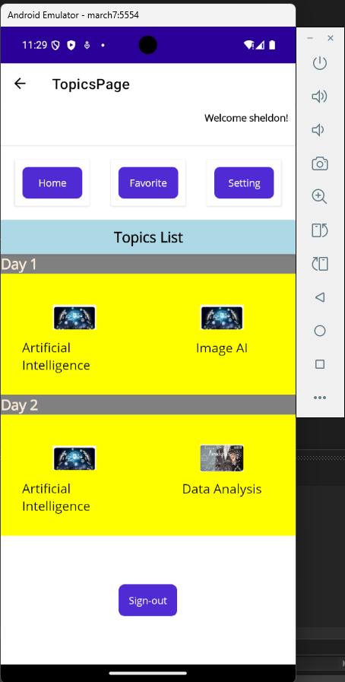
Favorite
Filter:
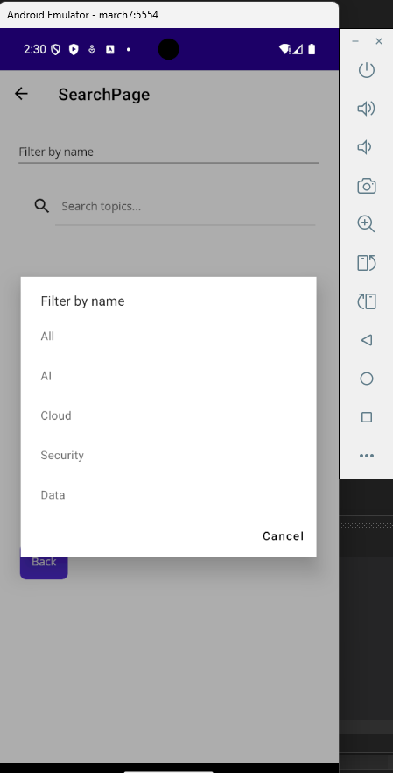
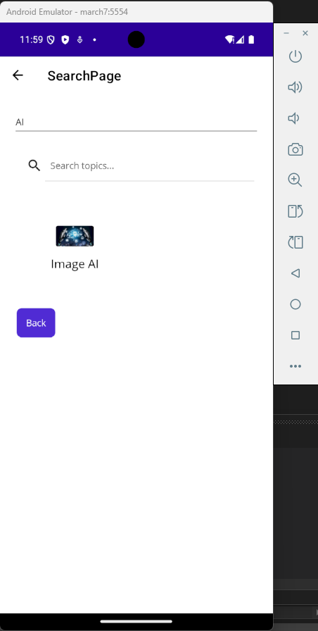
Search:
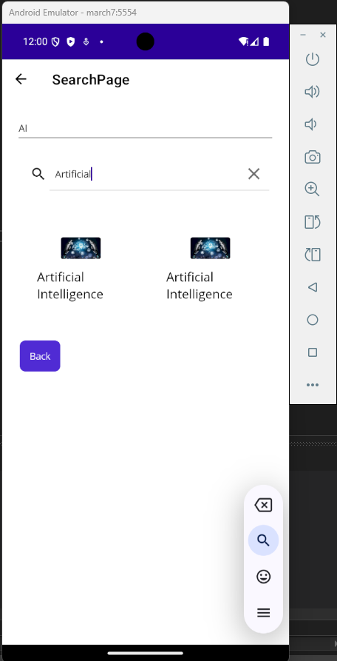
Setting Page
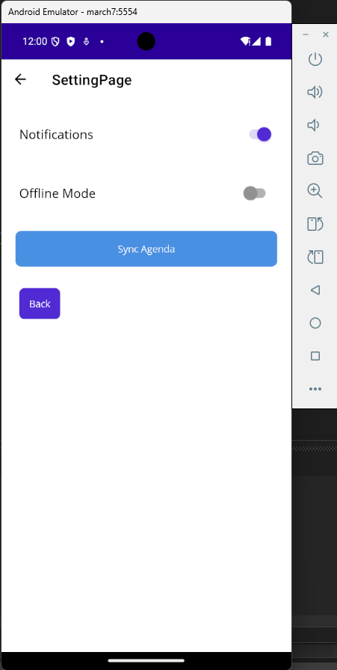
When clicking on “Companion Admin”.
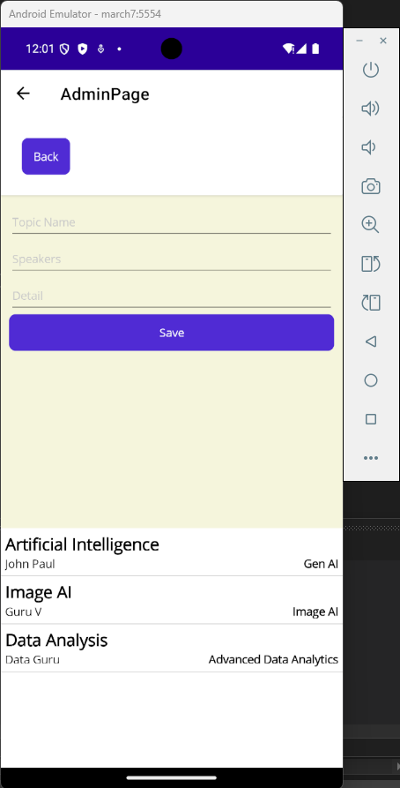
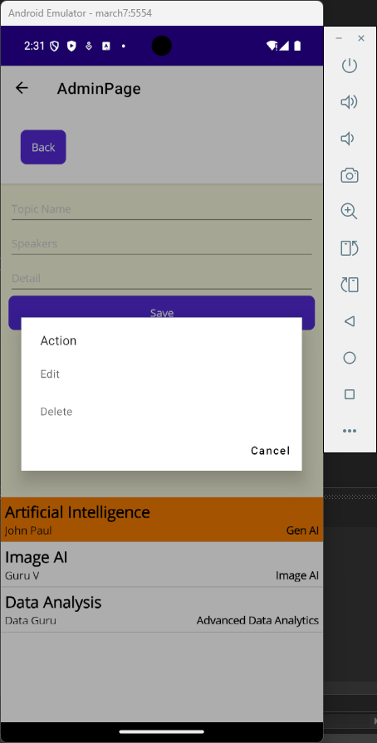
Click Edit button shows below:
